Meetinghouse Restoration Committee
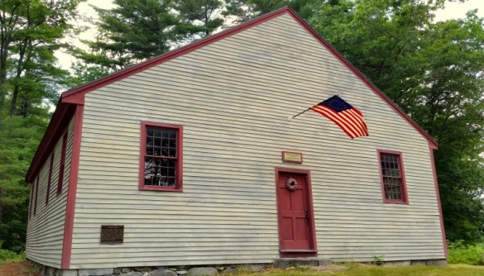
Public Meeting Agenda
Date: 5/8/19 Time: 7:00 PM Place: Library Posted: 5/7
I. Call to Order / II. Public Input

III. Business

- Planning

Town Meeting outcome / Objectives for the year

- Construction / Maintenance

Roof leaks
Attic catwalks / lights
Clean up day – May 18

- Outreach / Events

Dance event

- CRF / Fundraising / Grants

- Misc.

Committee Charge / BOS desire for term limits

IV. Any other business / Schedule Next Meeting / Adjournment

