TOWN OF NEW DURHAM
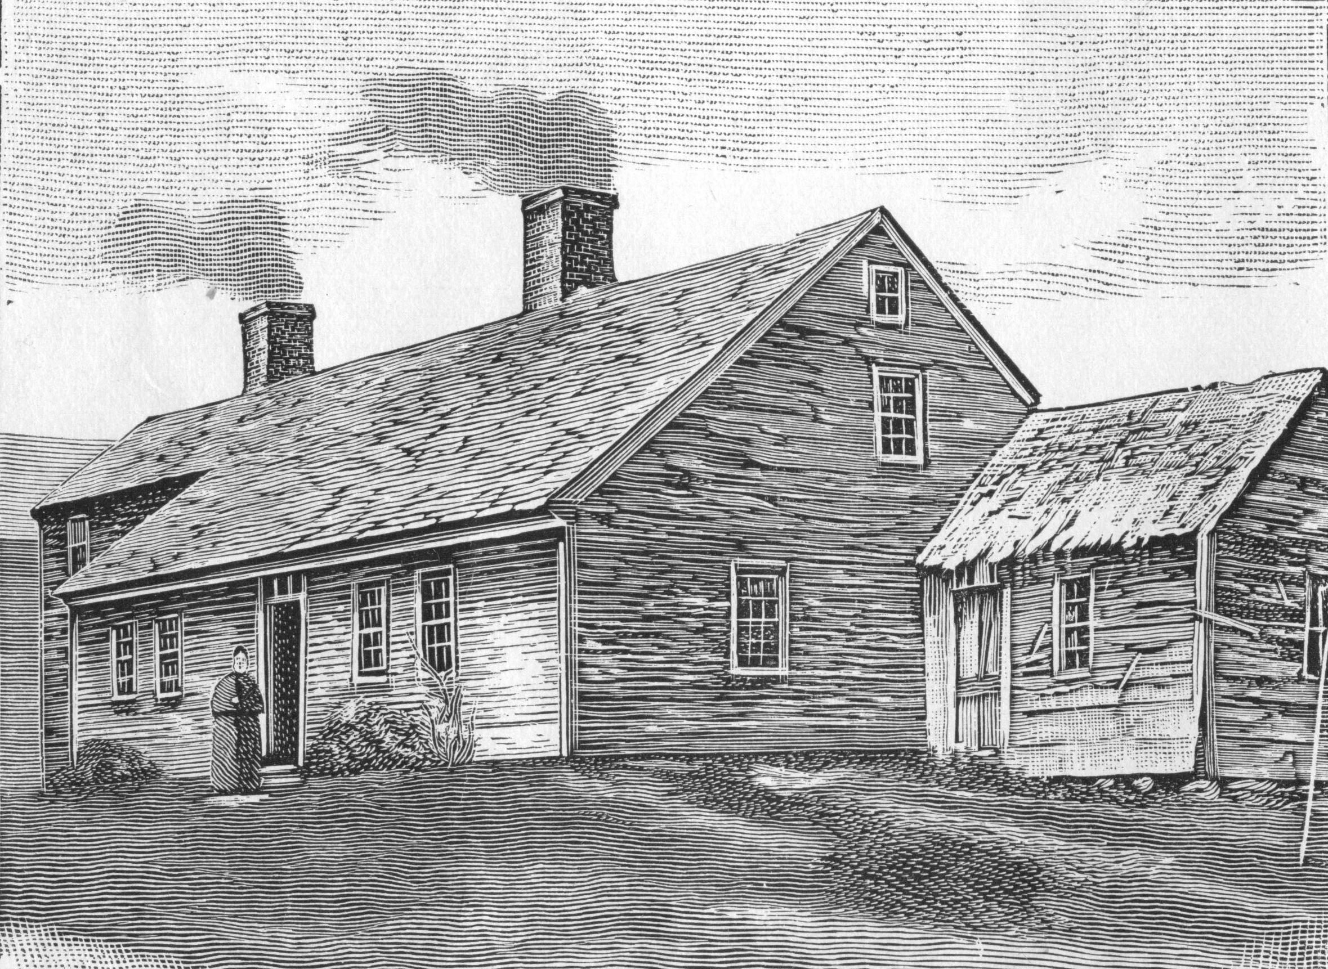
Zechariah Boodey Farmstead Committee
Schedule of Upcoming Meeting(s)
December 11, 2017

Monday, December 11, 2017
Time: 6:00 pm
Place: New Durham Town Hall
Agenda
- Review of Campaign letter.
- Any other business that may come legally before the committee.
- Adjourn to join BOS Meeting
Posted Thursday December 7, 2017

TOWN OF NEW DURHAM
Zechariah Boodey Farmstead Committee
Schedule of Upcoming Meeting(s)
December 11, 2017

Monday, December 11, 2017
Time: 6:00 pm
Place: New Durham Town Hall
Agenda
- Review of Campaign letter.
- Any other business that may come legally before the committee.
- Adjourn to join BOS Meeting
Posted Thursday December 7, 2017

